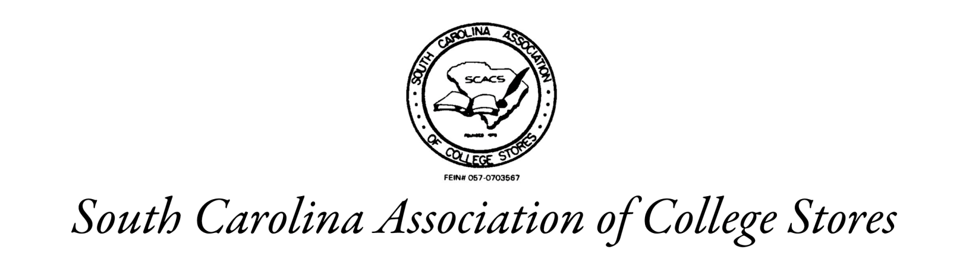

SCACS SPONSORSHIP INVOICE
Invoice #07022020, Due September 1, 2024

Company Name: __________________________________________________________________

Representative: ___________________________________________________________________

Address: ________________________________________________________________________

Your generous support allows us to provide professional speakers to enhance the educational sessions at our SCACS Conference. Your company will be recognized at the registration table, during meeting sessions, as well as in the program and the annual membership directory.

Pledged Donation Levels:

Diamond Level | $1000
Platinum Level | $500
Gold Level | $250
Silver Level | $100
Bronze Level | $50

Thank you for your sponsorship in support of this year’s SCACS Annual Meeting!

Checks made payable to: SCACS
Mail to: Upstate Bookstore
Attn: Cindy McAbee
800 University Way Spartanburg SC 29303

