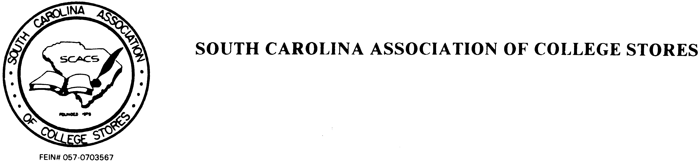

SCACS Annual Meeting
Scholarship Application - 2023

Please carefully review guidelines before completing and mailing this application. All sections must be completed for consideration. Only SCACS members in good standing are eligible to apply for a scholarship.

Name: _______________________________________

Title _________________________

Bookstore: _____________________________________________________________

Address: ______________________________________________________________

City: ___________________________________ State: _________ Zip: __________

Phone: _______________

E-mail: _______________________

I am applying for: SCACS 2023 Annual Meeting
Are you a first time attendee? ( ) Yes ( ) No

1. When was the last time someone from your store attended the annual meeting?

Event: _______________________________ Date: ______________

2. What is your store’s sales volume? _________________________________________

3. Will anyone else from your store be attending the event for which you are requesting
funds? ______________________________________________________________

4. Has your bookstore ever been awarded a SCACS scholarship? ( ) No ( ) Yes
If yes, when? ______________

5. How much funding are you requesting? (See guideline #4 for assistance.) $_________

To the SCACS Scholarship Committee: We are requesting a Scholarship to allow an individual from our store to attend the educational session/annual meeting selected. I believe the candidate will benefit by attending. I further certify time with pay (other than vacation time) will be granted. Funds requested are not otherwise available. Without this grant the individual would not be able to attend this program.

Signed: _____________________________ (Bookstore Manager) Date: ________________________

SCACS Scholarship Guidelines

SCACS Scholarship Committee shall follow these guidelines adopted in 1997 and later approved by the Executive Board and a vote from the general membership.

1. Scholarships are awarded by the SCACS Executive Board for educational programs.
Scholarship applications along with a completed SCACS registration form must be submitted 60 days prior to the opening date of the program to allow time for processing.

2. A completed scholarship application must be signed by the store manager indicating why the scholarship is necessary.

3. Scholarships are limited to one per store per fiscal year (Jan. 1 – Dec. 31).

4. Scholarships are provided to cover only tuition, registration, travel or lodging up to a maximum of $250.00 and are subject to the availability of funds.

5. A check for the amount of the scholarship in excess of the registration fee will be made payable to the store. Any unexpended funds must be returned to SCACS. If the applicant does not attend the program, the entire amount of funds awarded must be returned.

6. Scholarships have been established to promote attendance from stores which otherwise could not be represented. Scholarships will be awarded on the following priority:

(A). First time attendees
(B). Store sales volume of less than $500,000 per year
(C). Sales volume of more than $500,000 per year, or
(D). Attendance record.

7. SCACS will provide a Receipt Response Form with the scholarship. The scholarship Recipient will complete the form within 30 days after the program and return it to SCACS to be used for reporting purposes.

8. The SCACS Executive Board is solely responsible for all decisions regarding the Awarding of SCACS scholarships and reserves the right to accept or reject any Application.

9. SCACS Executive Board, the Scholarship Committee members, and their respective Stores are prohibited from receiving scholarships while serving the Association.

10. Stores requesting a scholarship must be SCACS members in good standing. Questions about SCACS scholarships can be directed to the SCACS Past Vice President. This year’s Past President is Rob Heller, who may be contacted with any questions at 843-356-2111 or by email: rheller@bncollege.com

“SCACS: Be Part of a Winning Team!”

